VIETNAM NATIONAL UNIVERSITY OF HO CHI MINH CITY
INTERNATIONAL UNIVERSITY
SCHOOL OF COMPUTER SCIENCE AND ENGINEERING


Lab 1

Course: Web Application Development
Instructor: Tran Khai Minh

Name and ID: Ngô Diễm Quỳnh ITITIU24054

Exercise 1:
<!DOCTYPE html>
<html lang="en">
<head>
<meta charset="UTF-8">
<meta name="viewport" content="width=device-width, initial-scale=1.0">
<title>Ex1</title>
<meta name="description" content="Personal CV of a Junior Frontend Developer">
<meta name="keywords" content="CV, Frontend Developer, HTML, CSS, JavaScript">
<meta name="author" content="Your Name">

<meta property="og:title" content="Your Name - CV">
<meta property="og:description" content="Personal CV of a Junior Frontend Developer">
<meta property="og:type" content="website">
<meta property="og:url" content="https://example.com">

<meta property="og:image" content="image.png">

<link rel="icon" type="image/png" href="favicon.png">
</head>

<body>
<main>
<div style="border: 2px solid black; padding: 50px; width: 700px; margin: 0 auto;">
<hr width="80%" align="left">
<h1>Your Name</h1>

<section>
<h2 style="color: green;">Junior Frontend Developer</h2>

<address>
123 Your Street <br>
Your City, State, ST 12345 <br>
(123) 456-7890 <br>
no_reply@example.com
</address>
</section>

<section></section>
<h2 style="color: green;">Skills</h2>
<p>HTML, CSS, JavaScript, Accessibility, Figma to Design, Responsive Web Design, Technical Writing, Presentation</p>
</section>

<section>
<h2 style="color: green;">Education</h2>
<p style="color: blue;">School Name, Location - Degree</p>
<p>Month 20xx to Month 20xx</p>
<p>List of exciting things you did at university</p>
</section>

<section>
<h2 style="color: green;">Experience</h2>
<p style="color: blue;">Company Name, Location - Job Title</p>
<p>Month 20xx to Month 20xx</p>
<ul>
<li>List of achievements</li>
<li>List of achievements</li>
<li>List of achievements</li>
</ul>
<p>Skill: List of skill used or gained at this company</p>
<p style="color: blue;">Company Name, Location - Job Title</p>
<p>Month 20xx to Month 20xx</p>
<ul>
<li>List of achievements</li>
<li>List of achievements</li>
<li>List of achievements</li>
</ul>
<p>Skill: List of skill used or gained at this company</p>
</section>

<section>
<h2 style="color: green;">Across the Internet</h2>
<p>Add your LinkedIn, GitHub profile links</p>
</section>
</div>
</main>

</body>
</html>

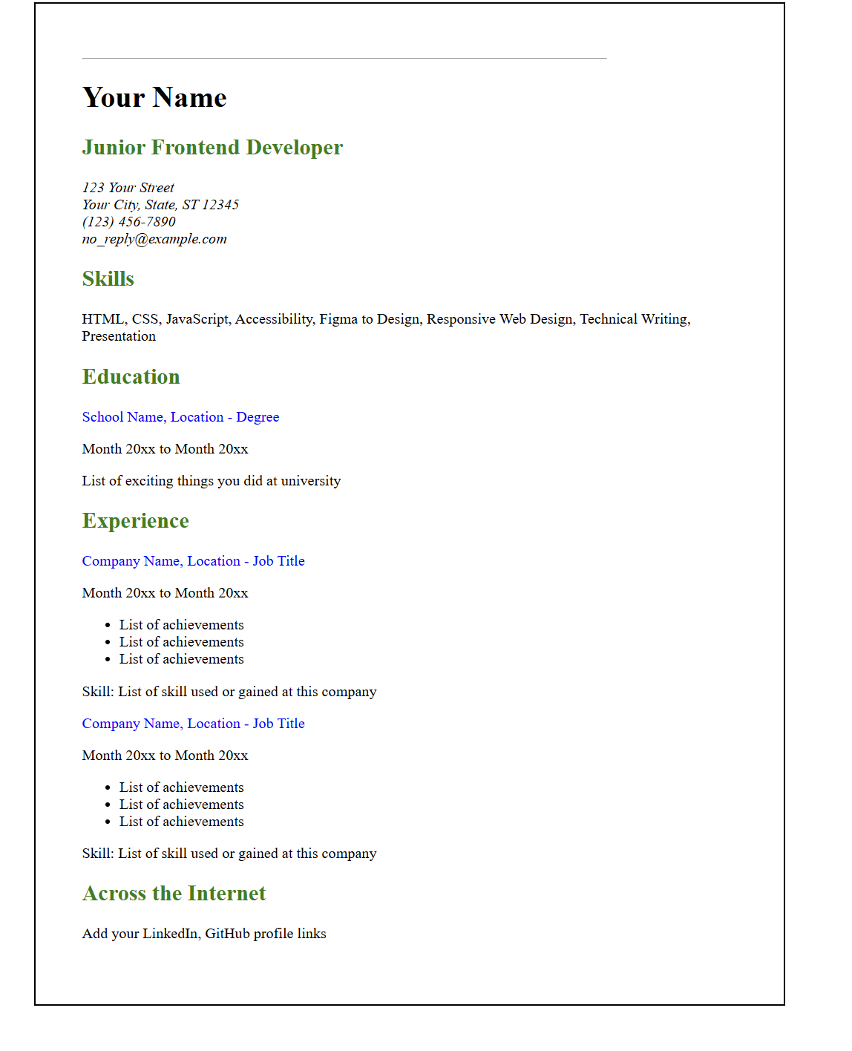
Exercise 2:
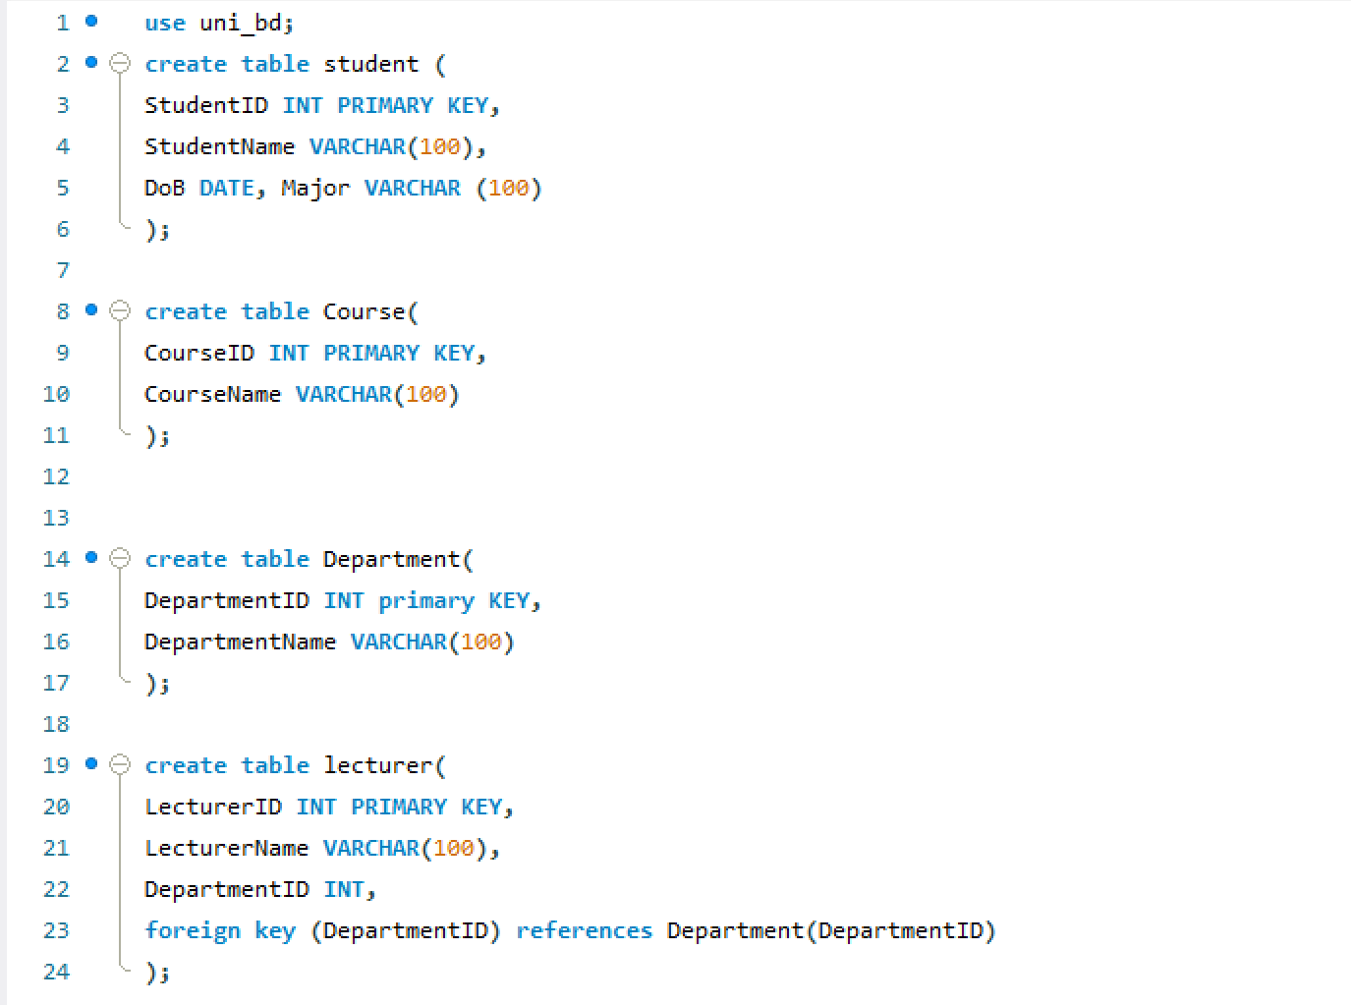

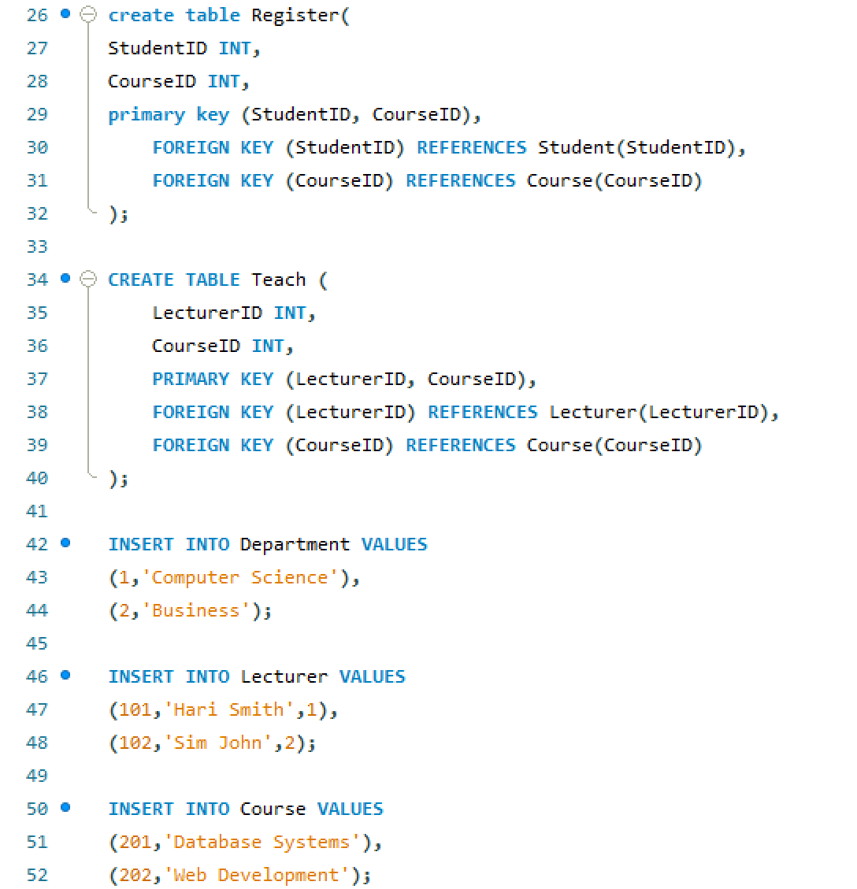
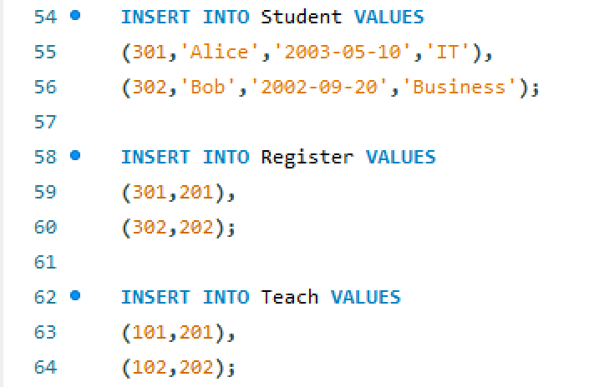

Conclusion:
his lab provided an introduction to the fundamental technologies used in web development: HTML and CSS. Students learned how to structure web pages using HTML and how to style them using CSS.
Through the in-class practice exercise, students applied these concepts by building a simple CV webpage. This activity helped reinforce the understanding of webpage structure and prepared students for more advanced web development tasks in future labs.

